Profil postavy

Yami no Goshin
“The Dad”

Lore
Nobody knows when He was born. But you can be sure He doesn't come from our age. He appears always when you least expect it. To thwart all the plans you have. A dark entity from ancient legends, where no one alive remembers them to tell.
Eyes full of fire piercing through the darkness. An inhuman face that will haunt you long after you wake from sleep. And a voice that will haunt you in your worst nightmares.
When little foxes refuse to listen, parents invoke the name of Yami no Goshin.
Yami no Goshin, a shadow of the past and a threat to the future, reminding us that there are forces beyond our understanding and that darkness can always be closer than we imagine.

Characterization
Yami no Goshin appears as the main antagonist throughout the entire story. However, he is revealed at the end to be the father of the main heroine, transforming from the archetype of The Ruler into the misunderstood Caregiver.

Visual description
Indeterminate age but definitely really old
White, long hair and lengthy beard
Very tall stature
Long and curved horns
Long and pointed fingers
Demonic face
Dark, inhuman eyes

Voice over reference
Kenjiro Tsuda, mainly in his role of Tatsu from The Way of the House Husband
Kenjiro Tsuda Reads Fan Comments | Netflix AnimeTatsu "SCARING" people compilation || The Way of the House Husband Season 1

Visual reference

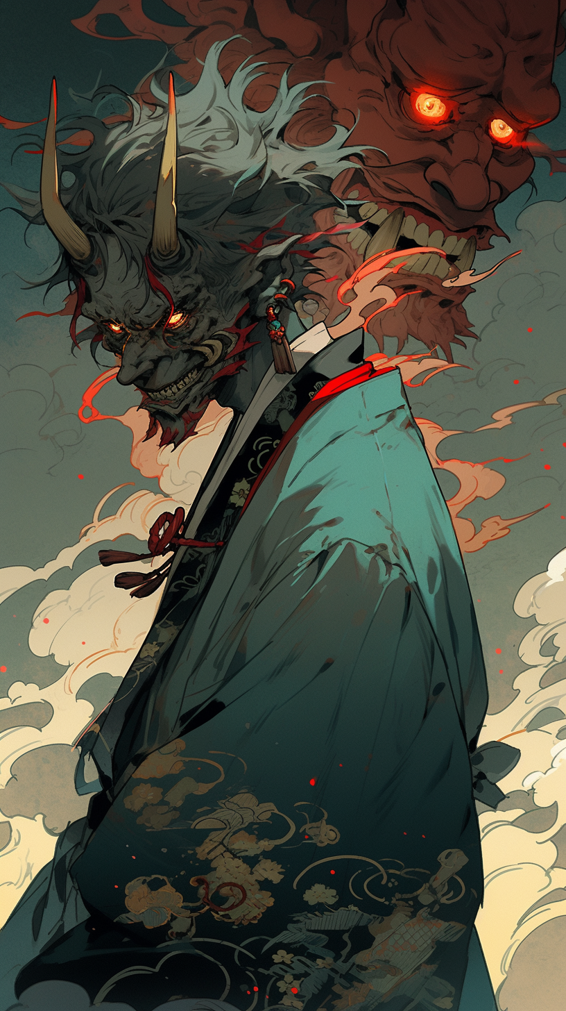
“The Bad Dad”
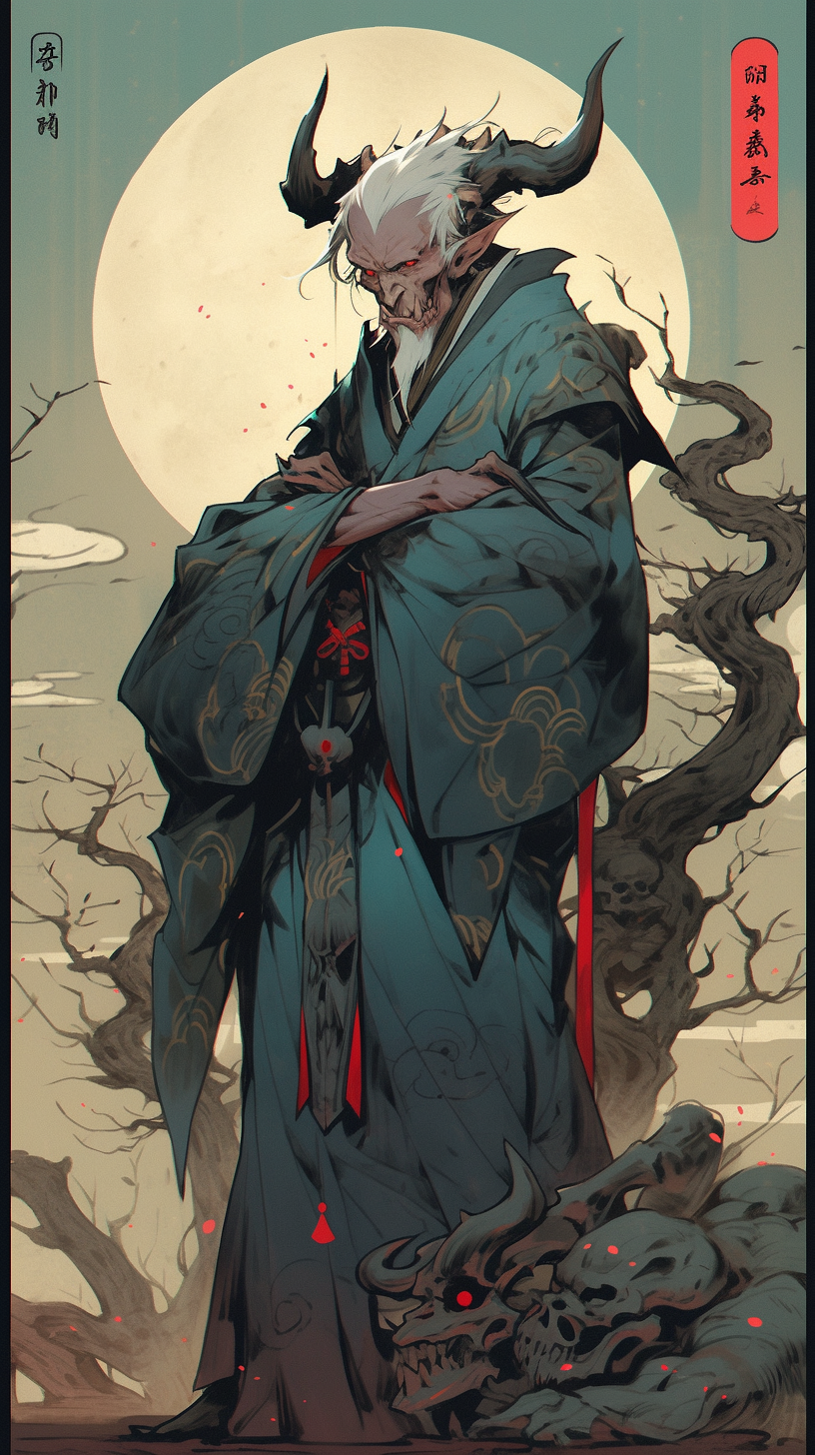
“The Good Dad”

